Answers to 2010 JJC H2 9647 Chemistry Prelim P3
∆H_{r}
1. |  | (a) | (i) |  | C(s) + CO₂(g)  2CO(g)  + 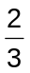Fe₂O₃(s)  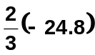  + Fe₂O₃(s)  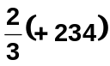  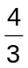Fe(s) + 2CO₂(g)  ∆H_{r} = 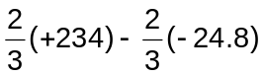  = +173 kJ mol^{–1} | [2]
 |  |  | (ii) |  | Top of the furnace (800ºC):  Lower temperature favours exothermic reaction. Hence, Reaction 2 is favoured to take place at the top of the furnace.  Bottom of the furnace (1500ºC):  Higher temperature favours endothermic reaction. Hence, Reaction 1 is favoured to take place at the bottom of the furnace. | [2]
 |  |  | (iii) |  | Reaction 1:  ∆G = ∆H – T∆S = +234 – 1073 (+0.279)  = – 65.4 kJ mol^{–1}  Reaction 2:  ∆G = ∆H – T∆S = –24.8 – 1073 (+0.0152)  = – 41.1 kJ mol^{–1}  Reaction 1 is thermodynamically more favourable as it has a more negative ∆G. | [3]
 |  |  | (iv) |  | 1) Reaction 2 is kinetically more favourable as iron(III) oxide reacts more readily with gaseous CO than with solid carbon where reaction can only take place at the interface of the two solids.  2) At 800ºC, there is not enough energy to overcome the high activation energy of reaction 1 due to breaking of strong C–C covalent bonds in solid carbon for reaction to take place.  3) Solid carbon will descend to the bottom of the blast furnace and gaseous carbon monoxide formed will rise to the top of the furnace (where temperature is 800ºC) to reduce the iron (III) oxide.
1. |  | (a) | (v) |  | C(s) + O=C=O (g)  2 C≡O (g)  ∆H_{r}  2(+1075)  ∆H_{a}(C)  + 2(+806)  2C(g) + 2O(g)  +173 + 2(1075) = ∆H_{a}(C) + 2(806)  ∆H_{a}(C) = +711 kJ mol^{–1} | [3]
 |  | (b)  Initial amt/ mol  Eqm amt/ mol | (i) |  | 3Fe(s) + 4H₂O(g)  Fe₃O₄(s) + 4H₂(g)  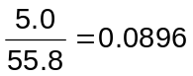  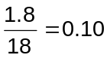  0 0  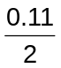 = 0.055  0.10 – 0.055  = 0.045  Eqm 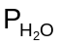 = 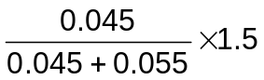 = 0.675 atm  Eqm 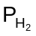 = 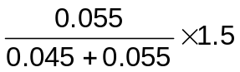 = 0.825 atm  K_{p} = 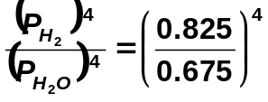 = 2.23 | [3]
 |  |  | (ii) |  | No change in equilibrium position (or equilibrium position does not shift).  When volume of the vessel is reduced, pressure is increased.  The equilibrium position is not affected by the pressure change because the number of gaseous molecules is the same on both sides of the equation. | [2]
1. |  | (c) | (i) |  | δ+ δ− δ  CH₂=CH₂ + Br ⎯ Br CH₂ CH₂ + :Br ⁻  Br  +  slow  fast  CH₂ CH₂  Br  Br | [2]
 |  |  | (ii) |  | Major product: CH₂ CH₂  OCH₃  Br | [1]
 |  |  | (iii) |  | Electrophilic Addition | [1]
 | 2. | (a) | (i) | .  .  .  C  Cl  .  .  .  .  .  .  Cl  .  ×  .  .  .  ×  .  ×  ×  The carbon atom in CCl₂ is electron-deficient as it has an incomplete octet configuration in its valence shell.  Hence, CCl₂ will attack the electron-rich benzene ring of phenol readily.
 |  |  | (ii) | The carbon atom in −CHCl₂ group is highly electron-deficient as it is bonded to two electron-withdrawing chlorine atoms. Hence, this carbon atom is readily attacked by the hydroxide ion nucleophile.
 |  | (b)  OH  C | (i) | Mechanism: Nucleophilic addition  HCN  H⁺ + CN⁻  CN⁻  .  .  OH  C  O  H  CN  −  OH  O  δ−  HO  H  fast  δ+  slow  HCN  C  + CN⁻  H  CN
 |  |  | (ii) | Reaction IV: LiAlH₄, dry ether OR NaBH₄, dry ether  Reaction V: Limited CH₃Cl , heat in a sealed tube
 |  |  | (iii) | Reagent: PCl₅  Observation : L will give white fumes of HCl.
 |  |  | (iv) | OH  C  H  NCH₂CH₂N  C  H  OH  N
 |  | (c) | When dilute NaOH(aq) is added to Al(NO₃)₃(aq), white ppt. of Al(OH)₃ is formed, which dissolves in excess NaOH to give a colourless solution.  Al³⁺(aq) + 3OH–(aq) → Al(OH)₃(s)  Al(OH)₃(s) + OH–(aq) → [Al(OH)₄]–(aq)  When dilute NaOH(aq) is added to Mg(NO₃)₂(aq), white ppt. of Mg(OH)₂ is formed, which is insoluble in excess NaOH.  Mg²⁺(aq) + 2OH–(aq) → Mg(OH)₂(s)  When dilute NaOH(aq) is added to Ba(NO₃)₂(aq), no ppt.is formed.
 | 2. | (d) | Since Na⁺ has a low charge density, Na⁺ does not undergo hydrolysis. Hence, a neutral solution of pH 7 is obtained.  Due to high charge density of Al³⁺, Al³⁺ undergoes vigorous hydrolysis to give an acidic solution of pH 3.  Hydrolysis: [Al(H₂O)₆]³⁺(aq) → [Al(H₂O)₅OH]²⁺(aq) + H⁺(aq)
 |  | (e)  Ionic radius / nm | (i) | 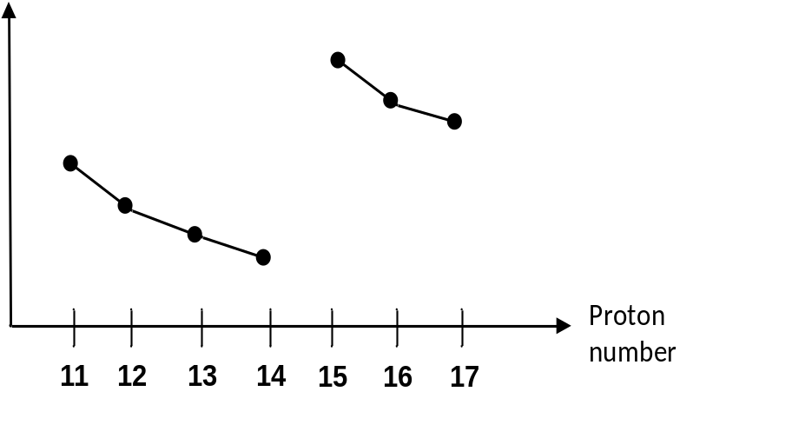  #  Na  Mg  Al  P  Si
 |  |  | (ii) | From Na⁺ to Si⁴⁺,  ionic radii of the isoelectronic ions decrease due to increase in nuclear charge while the shielding effect by inner shell electrons remains constant.  P³⁻ has a larger ionic radius than the cations as it has one more principal quantum shell of electrons.

3. | (a) | In a glucose molecule, there are five –OH groups which are capable of forming hydrogen bonding with water molecules. Therefore, glucose is extremely soluble in water due to its extensive hydrogen bonding with water molecules.  The large hydrophobic(non-polar) group of hexan-1-ol molecule hinders the formation of hydrogen bonding with water molecules, thus hexan-1-ol is only slightly soluble in water.
 | (b) | A red-brown precipitate is formed.  Glucose reduces the Cu²⁺ complex in Fehling’s solution to form a red-brown ppt. of copper(I) oxide (Cu₂O), and glucose itself is being oxidised to a carboxylate salt.  In this reaction, the oxidation number of Cu decreases from +2 to +1.
 | (c) | (i) | Type of reaction: Ester formation  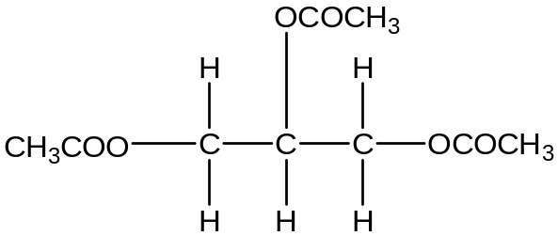
3. | (c) | (ii) | Type of reaction: Substitution  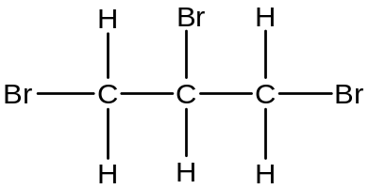
 | (d) | Acid strength: glycerol < phenol < ethanoic acid.  Ethanoic acid is the strongest acid because the CH₃COO⁻ ion is stabilised as the negative charge on the O atom is dispersed by the delocalisation of the negative charge over the two O atoms.  C  O  O  H₃C  _  Phenol is a stronger acid than glycerol. The lone pair of electrons on the O atom of phenoxide ion can be delocalised into the benzene ring, thereby disperses the negative charge on the O atom of the phenoxide ion and hence stabilises the phenoxide ion.
 | (e) | (i) |  | At the anode: C₆H₁₂O₆ → C₆H₁₀O₆ + 2H⁺ + 2e⁻  At the cathode: O₂ + 4H⁺ + 4e⁻ → 2H₂O
 |  | (ii) |  | Overall: O₂ + 2C₆H₁₂O₆ → 2C₆H₁₀O₆ + 2H₂O
 |  | (iii) |  | E_{cell} = +1.23 − E(C₆H₁₀O₆/C₆H₁₂O₆) = +0.80 V  E(C₆H₁₀O₆/C₆H₁₂O₆) = +1.23 – 0.80  = +0.43 V
 |  | (iv) |  | Amount of electrons generated each day  = (0.36 x 24 x 60 x 60) / 96500 = 0.322 mol  Since glucose(C₆H₁₂O₆) ≡ 2e⁻,  Mass of glucose consumed each day  = ½ x 0.322 x 180.0  = 29.0 g
 |  | (v) |  | In areas of high temperatures, the weaker R-group interactions in the tertiary structure of the enzymes will be disrupted.  These weak R-group interactions are van der Waals’ forces of attraction and hydrogen bonding,  As such, the enzymes in the battery will be denatured (or lost its function) as the conformation (or shape) of active sites of the enzymes is altered.

4. | (a) | (i) | Solubility of a substance is the maximum amount (or mass) of the substance dissolved in a given volume of a particular solvent to give a saturated solution at a specified temperature.
 |  | (ii) | Let x mol dm^{–3} be the solubility of Ag₂CrO₄ at 25°C.  Ag₂CrO₄(s)  2Ag⁺(aq) + CrO₄²⁻(aq)  At eqm 2x x  K_{sp} of Ag₂CrO₄ = [Ag⁺]² [CrO₄²⁻] Units: mol³ dm⁻⁹  1.1 x 10⁻¹² = (2x)²(x) = 4x³  x = 6.50 x 10⁻⁵  Solubility of Ag₂CrO₄ at 25°C is 6.50 x 10⁻⁵ mol dm^{–3}
 |  | (iii) | AgCl(s)  Ag⁺(aq) + Cl⁻(aq)  y y  Let y mol dm^{–3} be the solubility of AgCl at 25°C.  K_{sp} = [Ag⁺][ Cl⁻]  1.8 x 10⁻¹⁰ = y² ⇒ y = 1.34 x 10⁻⁵  Solubility of AgCl at 25°C is 1.34 x 10⁻⁵ mol dm⁻³  Since solubility of AgCl is smaller than that of Ag₂CrO₄, AgCl will precipitate before Ag₂CrO₄.
 |  | (iv) | When NH₃(aq) is gradually added, red ppt dissolves (first). On adding excess NH₃(aq), white ppt dissolves.  The colour of the resulting solution is yellow.  When aqueous ammonia is added, Ag(NH₃)₂⁺ complex is formed.  AgCl(s)  Ag⁺(aq) + Cl⁻(aq) ---(1)  Ag₂CrO₄(s)  2Ag⁺(aq) + CrO₄²⁻(aq) ---(2)  Due to the formation of this complex, concentration of Ag⁺(aq) decreases such that both equilibrium positions of (1) and (2) shift to the right, thereby increasing the solubility of AgCl and Ag₂CrO₄ in NH₃(aq).  Ag₂CrO₄ dissolves before AgCl because Ag₂CrO₄ is more soluble than AgCl.
4. | (b) | (i) | yellow or yellow-brown (due to Fe(H₂O)₆³⁺)
 |  | (ii) | Transition element complexes are coloured because of electron transition between d orbitals.  In a complex ion, the presence of ligands causes the 3d orbitals to split into two sets of different energies.  The difference in energies (energy gap ΔE) between these two sets of 3d orbitals is so small such that visible light (or radiation from the visible region of the electromagnetic spectrum) is absorbed when a 3d electron moves from a d orbital of lower energy to another unfilled or partially filled d orbital of higher energy.  Hence, transition metal complexes are coloured and the colour seen is the complement of the colours absorbed.
 |  | (iii) | [Fe(H₂O)₅SCN]²⁺  SCN⁻ is a stronger ligand than H₂O. It displaces H₂O ligand to form a stronger dative bond with Fe³⁺ and hence a more stable red [Fe(H₂O)₅(SCN)]²⁺ complex is formed.
 |  | (iv) | Ag⁺ ≡ SCN⁻≡ AgSCN  Amount of SCN⁻ required  = 13.75/1000 x 1.40 x 10⁻³  = 1.93 x 10⁻⁵ mol  = Amount of excess Ag⁺ (left unreacted)  Amount of Ag⁺ reacted with Cl⁻  = Amount of Cl⁻ in the water sample  = (25.00/1000 x 1.30 x 10⁻³) − 1.93 x 10⁻⁵  = 1.33 x 10⁻⁵ mol  Concentration of Cl⁻ in water sample  = 1.33 x 10⁻⁵ x 1000/25.00  = 5.30 x 10⁻⁴ mol dm⁻³

5. | (a) | (i) | CH₃CHCH₂CO₂–  CH₃  CH₃CHCH₂CO₂H  CH₃  [H⁺]  K_{a} =

 |  | (ii) | pK_{a} = 4.80 ⇒ K_{a} = 10^{–4.80} = 1.58 x 10⁻⁵ mol dm^{–3}  [H⁺] = √ 1.58 x 10⁻⁵ x 0.50  = 2.81 x 10⁻³ mol dm^{–3}  pH = – log₁₀ (2.81 x 10⁻³) = 2.55 [1m]

 |  | (iii) | [CH₃CH(CH₃)CH₂COO–Na⁺]  = (10.0/1000 x 0.50) / (35.0/1000)  = 0.143 mol dm^{–3}  [CH₃CH(CH₃)CH₂COOH]  = (15.0/1000 x 0.50) / (35.0/1000)  = 0.214 mol dm^{–3}  pH = pKa + lg [salt]/[acid]  = 4.80 + lg(0.143/0.214)  = 4.62
5. | (b) | Both isovaleric acid and 1-chloro-3-methyl butane have a simple molecular/covalent structure.  Even though they have similar M_{r}, they have different types of intermolecular forces.  Larger amount of energy is required to break the stronger hydrogen bonds between isovaleric acid molecules [1m] than the weaker permanent dipole-permanent dipole interactions between CH₃CH(CH₃)CH₂CH₂Cl molecules.  Therefore, isovaleric acid has a higher boiling point than 1-chloro-3-methylbutane.
 | (c) | (i) | The empirical formula of P is C₅H₉O₂Cl.  M_{r} of C₅H₉O₂Cl = 5(12.0) + 9(1.0) + 2(16.0) + 35.5 = 136.5  Therefore, molecular formula of P is C₅H₉O₂Cl.
   | C | H | Cl | O
  % mass | 44.0 | 6.6 | 26.0 | 23.4
  Amount/mol | 3.67 | 6.6 | 0.732 | 1.46
  Mole ratio | 5 | 9 | 1 | 2
5.(c)(ii)
H CH₃
H C C* CH₂COOH
Cl H
H CH₃
H C C* CH₂COOH
OH H
H H
C C
O C
C
O
CH₃
H
H
H
H CH₃
C = C
H CH₂COOH
CH₃ C CH₂COOH
O
O O
C CH₂ C
⁺Na–O O–Na⁺

P (C₅H₉O₂Cl)
Na₂CO₃(aq)
{acid-carbonate reaction}
P dissolves.
NaOH(aq), followed by acidification
{acid-base reaction of carboxylic acid}
{nucleophilic substitution/alkaline hydrolysis of alkyl halide}
Q (C₅H₁₀O₃)
reflux with
conc. H₂SO₄
{ester formation/ esterification}
{dehydration/
elimination}
R (C₅H₈O₂)
S (C₅H₈O₂)
acidified KMnO₄, heat
{oxidation with cleavage of C=C}
T (C₄H₆O₃)
warm I₂ in NaOH(aq)
{positive iodoform /triiodomethane test
or oxidation}
U (C₃H₂O₄Na₂)
CHI₃(s) +

